**Spring Core – Load Country from Spring Configuration XML**

An airlines website is going to support booking on four countries. There will be a drop down on the home page of this website to select the respective country. It is also important to store the two-character ISO code of each country. 

|  |  |
| --- | --- |
| **Code** | **Name** |
| US | United States |
| DE | Germany |
| IN | India |
| JP | Japan |

Above data has to be stored in spring configuration file. Write a program to read this configuration file and display the details.

**STRUCTURE:**

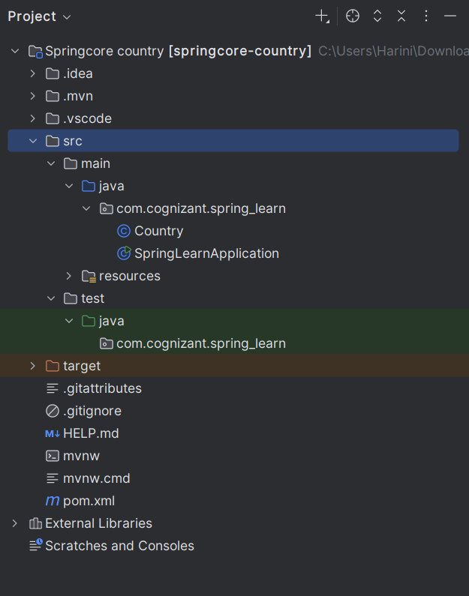

**CODE:**

**Country.java:**

package com.cognizant.spring_learn;  
  
import org.slf4j.Logger;  
import org.slf4j.LoggerFactory;  
  
public class Country {  
 private static final Logger *LOGGER* = LoggerFactory.*getLogger*(Country.class);  
  
 private String code;  
 private String name;  
  
 public Country() {  
 *LOGGER*.debug("Inside Country Constructor.");  
 }  
  
 public String getCode() {  
 *LOGGER*.debug("Getting country code: {}", code);  
 return code;  
 }  
  
 public void setCode(String code) {  
 *LOGGER*.debug("Setting country code: {}", code);  
 this.code = code;  
 }  
  
 public String getName() {  
 *LOGGER*.debug("Getting country name: {}", name);  
 return name;  
 }  
  
 public void setName(String name) {  
 *LOGGER*.debug("Setting country name: {}", name);  
 this.name = name;  
 }  
  
 @Override  
 public String toString() {  
 return "Country [code=" + code + ", name=" + name + "]";  
 }  
}

**SpringLearnApplication.java:**

package com.cognizant.spring_learn;  
  
import org.slf4j.Logger;  
import org.slf4j.LoggerFactory;  
import org.springframework.context.ApplicationContext;  
import org.springframework.context.support.ClassPathXmlApplicationContext;  
  
public class SpringLearnApplication {  
 private static final Logger *LOGGER* = LoggerFactory.*getLogger*(SpringLearnApplication.class);  
  
 public static void main(String[] args) {  
 *displayCountry*();  
 }  
  
 public static void displayCountry() {  
 ApplicationContext context = new ClassPathXmlApplicationContext("country.xml");  
 Country country = (Country) context.getBean("country", Country.class);  
 *LOGGER*.debug("Country: {}", country.toString());  
 }  
}

**SpringLearnApplicationTests.java:**

package com.cognizant.spring_learn;  
  
import org.slf4j.Logger;  
import org.slf4j.LoggerFactory;  
import org.springframework.context.ApplicationContext;  
import org.springframework.context.support.ClassPathXmlApplicationContext;  
  
public class SpringLearnApplication {  
 private static final Logger *LOGGER* = LoggerFactory.*getLogger*(SpringLearnApplication.class);  
  
 public static void main(String[] args) {  
 *displayCountry*();  
 }  
  
 public static void displayCountry() {  
 ApplicationContext context = new ClassPathXmlApplicationContext("country.xml");  
 Country country = (Country) context.getBean("country", Country.class);  
 *LOGGER*.debug("Country: {}", country.toString());  
 }  
}

**application.properties:**

# Log level config  
logging.level.root=INFO

**Country.xml:**

<?xml version="1.0" encoding="UTF-8"?>  
<beans xmlns="http://www.springframework.org/schema/beans"  
 xmlns:xsi="http://www.w3.org/2001/XMLSchema-instance"  
 xsi:schemaLocation="http://www.springframework.org/schema/beans  
 https://www.springframework.org/schema/beans/spring-beans.xsd">  
  
 <bean id="country" class="com.cognizant.spring_learn.Country">  
 <property name="code" value="IN" />  
 <property name="name" value="India" />  
 </bean>  
  
</beans>

**Pom.xml:**  
<project xmlns="http://maven.apache.org/POM/4.0.0"  
 xmlns:xsi="http://www.w3.org/2001/XMLSchema-instance"  
 xsi:schemaLocation="http://maven.apache.org/POM/4.0.0  
 http://maven.apache.org/xsd/maven-4.0.0.xsd">  
   
 <modelVersion>4.0.0</modelVersion>  
  
 <groupId>com.cognizant</groupId>  
 <artifactId>springcore-country</artifactId>  
 <version>0.0.1-SNAPSHOT</version>  
  
 <dependencies>  
 <!-- Spring Context for Core container and XML config -->  
 <dependency>  
 <groupId>org.springframework</groupId>  
 <artifactId>spring-context</artifactId>  
 <version>6.1.5</version>  
 </dependency>  
  
 <!-- Logging support (SLF4J + Logback) -->  
 <dependency>  
 <groupId>org.slf4j</groupId>  
 <artifactId>slf4j-api</artifactId>  
 <version>2.0.13</version>  
 </dependency>  
 <dependency>  
 <groupId>ch.qos.logback</groupId>  
 <artifactId>logback-classic</artifactId>  
 <version>1.4.14</version>  
 </dependency>  
 </dependencies>  
  
 <build>  
 <plugins>  
 <plugin>  
 <groupId>org.codehaus.mojo</groupId>  
 <artifactId>exec-maven-plugin</artifactId>  
 <version>3.1.0</version>  
 <configuration>  
 <mainClass>com.cognizant.spring_learn.SpringLearnApplication</mainClass>  
 </configuration>  
 </plugin>  
 </plugins>  
</build>  
  
</project>

**OUTPUT:**

